past DBMS exam paper (2020/2021), here’s a new set of exam-style questions

1️⃣ Disk and I/O Calculations (6 points)
A disk rotates at 6000 rpm, has 10,000 tracks per surface, and 6 surfaces.
Each track has 24 sectors, and each sector holds 1024 bytes.
Blocks consist of 2 sectors.
20% of the track circumference is used for gaps.
The head movement time for n tracks is 1 + 0.002n ms.
a) Compute the transfer time for one block.
b) If the head is currently at track 1 and we need to read from track 6000, how long does it take to move the head to the target track?2️⃣ B+ Tree Operations (9 points)
Consider a B+ Tree of order 4.
a) Insert keys in the order: 5, 25, 10, 20, 35. Draw the resulting tree after all insertions.
b) Delete key 15 from the tree (Do not use the result of a)!
c) What is the maximum number of keys that can be indexed in a B+ tree of order 4 with five levels (including root)?
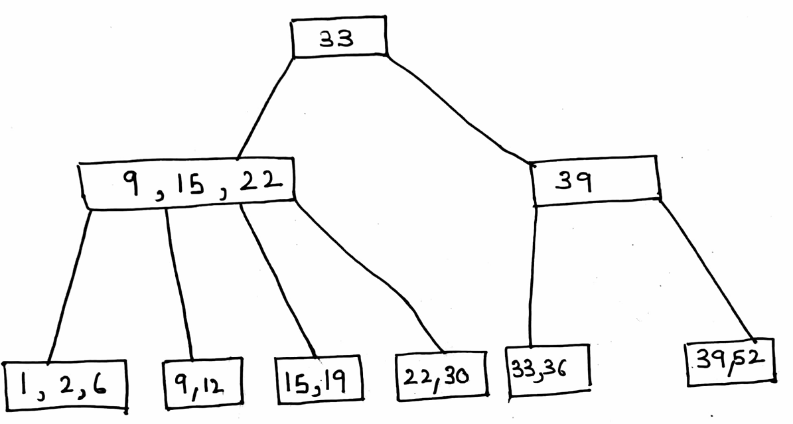

3️⃣ Data Representation & Storage (13 points)
A relation R(A, B, C) is to be stored on disk.
- A: 12 bytes
- B: 24 bytes
- C: 30 bytes
Each record also has a record header of 10 bytes.
A block has a header of 64 bytes, and block size = 4096 bytes.
The relation has T(R) = 50,000 records.
a) Calculate the minimum number of blocks needed for unspanned storage.
b) Repeat (a) assuming spanned storage of records.
c) Suppose we build a dense index on attribute B. The pointer size is 8 bytes, and index records have no headers. Calculate the number of blocks for the index file.
d) If we perform the projection 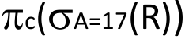, assuming no duplicates, how many blocks are needed for the result relation?

4️⃣ Join Order Optimization (6 points)
We have relations A(a, b), B(b, c), and C(c, d).
T(A) = 200, V(A, a) = 50, V(A, b) = 20
T(B) = 800, V(B, b) = 40, V(B, c) = 80
T(C) = 1000, V(C, c) = 100, V(C, d) = 10
Find:
a) The join order chosen by the greedy algorithm for joining A, B, and C.
b) Compute the intermediate relation sizes for each step and total cost (sum of intermediate sizes).

5️⃣ Index Join Cost (6 points)
Relations R(A, B) and S(B, C) have these statistics:
T(R) = 200,000, B(R) = 5,000, V(R, A) = 50,000, V(R, B) = 10,000
T(S) = 80,000, B(S) = 10,000, V(S, B) = 80,000, V(S, C) = 20,000
Attribute B is a key in S and a foreign key in R.
There is a B-tree index on S.B with 4 levels.
a) Compute I/O cost if the entire index is in memory.
b) Compute I/O cost if only the root of the index is in memory (other levels on disk).
Assume both relations are clustered and contiguous.

6️⃣ Addressing, TID, and Swizzling (6 points)
a) Explain the difference between physical and logical addressing in a DBMS. Include one advantage and one disadvantage of each.
b) Define a Tuple Identifier (TID) and explain how it helps avoid dangling pointers.
c) Describe the three pointer swizzling strategies and state when each is most efficient.

✅ Topics Covered
- Disk structure & access time
- B+ tree operations
- Record & block storage
- Index and projection storage
- Join order optimization
- Index-based join I/O
- Addressing & pointer management

model solutions (step-by-step) for Questions 3–6, based on your DBMS 2020/2021-style exam.

solved only part (c) of Q.2 of the B+-Tree question clearly and step-by-step.

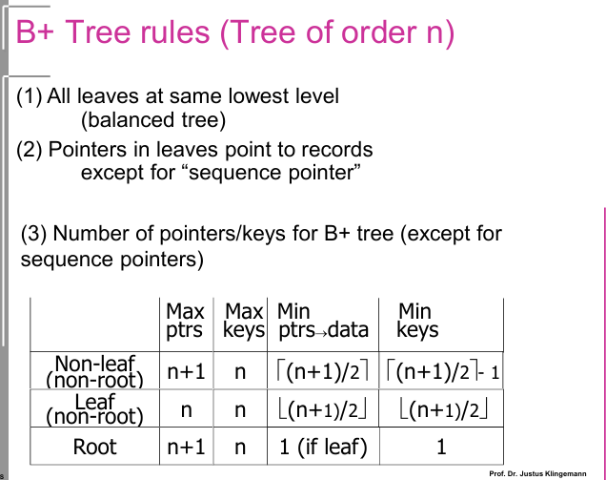

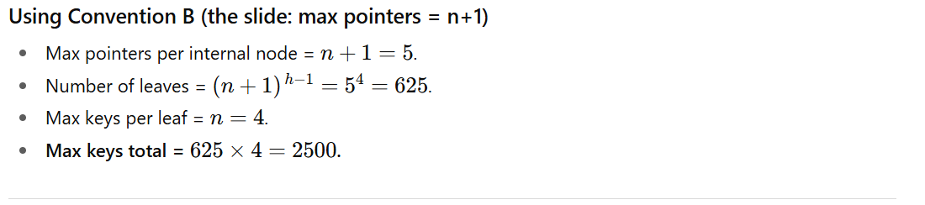
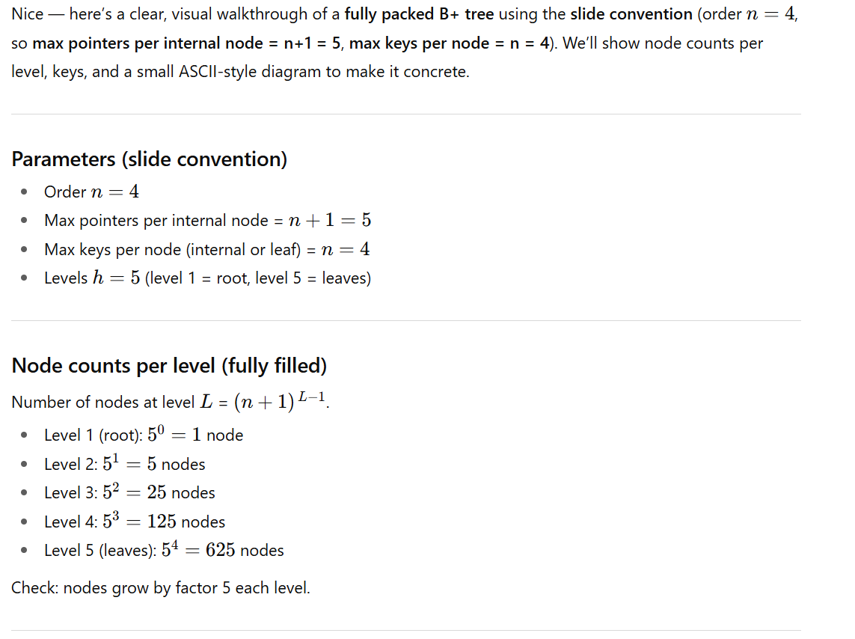

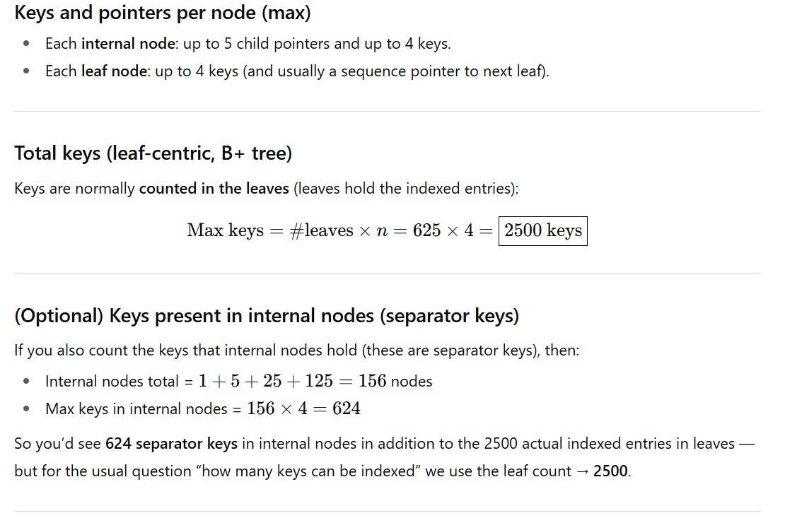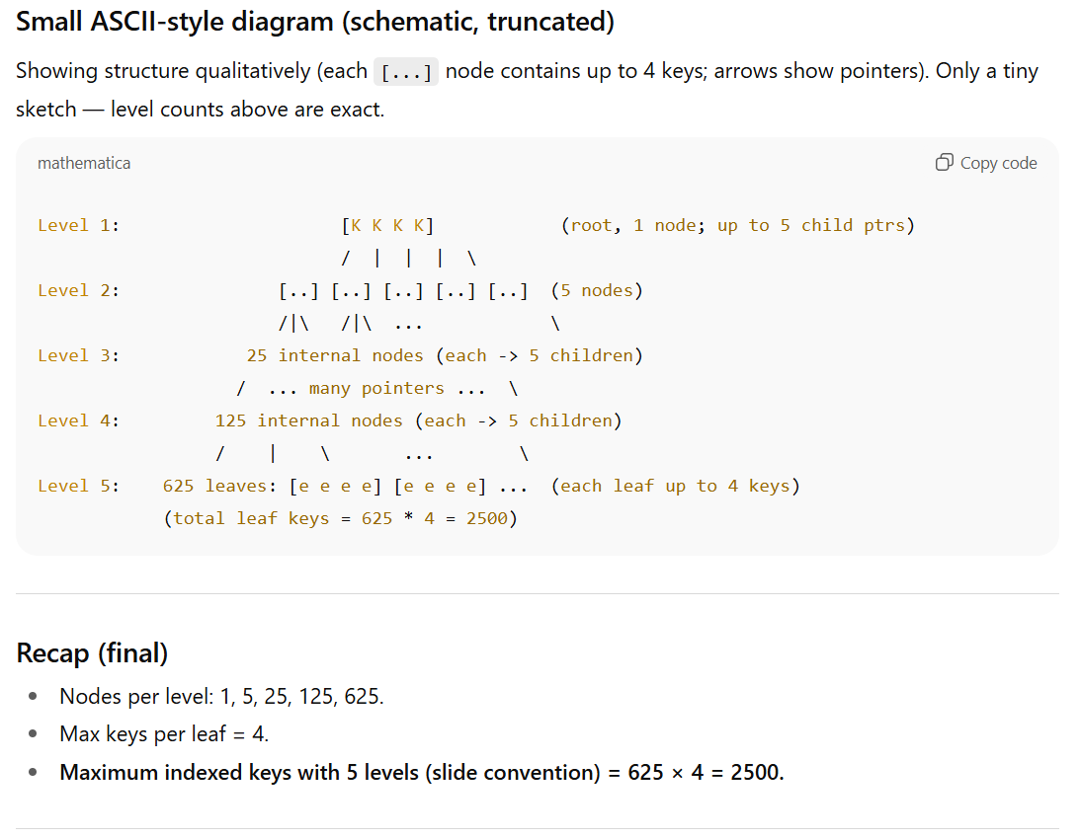

We’ll now find the minimum number of keys that can be indexed in a B+ tree of order 4 with 5 levels (including root), following the same slide convention.
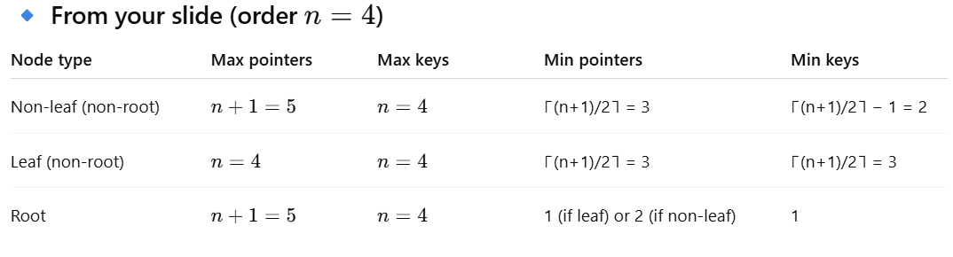

⚙️ Given
- n = 4
- Height = 5 (levels including root)
- Therefore:
  - Root has at least 2 pointers → 1 key
  - Every internal node (non-root) has ≥ 3 pointers → ≥ 2 keys
  - Every leaf has ≥ 3 keys

🧮 Step 1: Minimum number of leaf nodes
Each internal node (except root) must have at least 3 pointers.
That means each node at level ii points to 3 nodes at the next level.
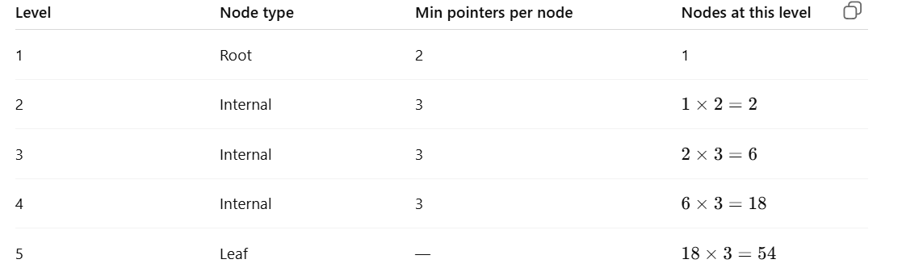
✅ Minimum number of leaf nodes = 54

🧮 Step 2: Minimum keys per leaf
From the table: each leaf has ≥ 3 keys.
So:
Minimum total keys = 54 × 3 = 162

🧮 Step 3 (Optional): Keys in internal nodes
(Usually not counted when we say "keys indexed" — but for completeness:)
- Level 1 (root): 1 key
- Level 2–4 (non-leaf): each node ≥ 2 keys
If counted, internal keys total 1 + 2×2 + 6×2 + 18×2 = 1 + 4 + 12 + 36 = 53.
So total keys (including separators) 162 + 53 = 215.

✅ Final Answers
Measure | Result
Minimum indexed (leaf) keys | 162
Minimum total keys (including internal) | 215

🔹 Summary
Tree Order | Levels | Max Keys | Min Keys
4 | 5 | 2500 | 162

🧩 Question 3 — Data Representation & Storage
Given:
A = 12 bytes, B = 24 bytes, C = 30 bytes
Record header = 10 bytes
→ Record size = 12 + 24 + 30 + 10 = 76 bytes

Block header = 64 bytes
Block size = 4096 bytes
Usable block space = 4096 – 64 = 4032 bytes
T(R) = 50,000 records

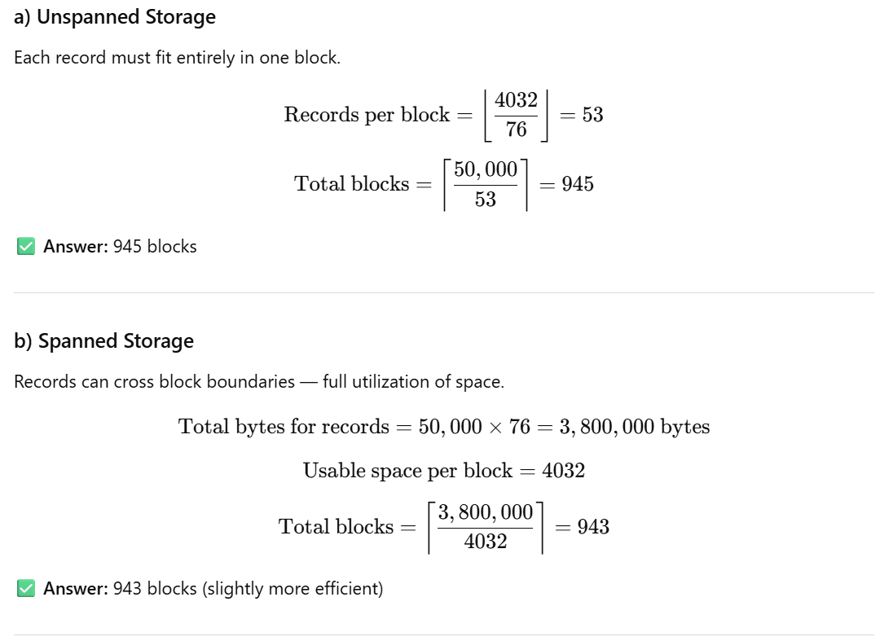

c) Dense Index on B
- One index entry per record.
- Each index record = (Key + Pointer)
  - Key (B): 24 bytes
  - Pointer: 8 bytes
  - → 32 bytes per index entry.

✅ Answer: 397 index blocks

d) Projection π₍C₎(R)
- C = 30 bytes
- Assume no duplicates and no header (or minimal per tuple header of 10 bytes).
  - Record size = 40 bytes

✅ Answer: 500 blocks

✅ Summary (Q3)
Part | Concept | Answer
(a) | Unspanned | 945 blocks
(b) | Spanned | 943 blocks
(c) | Dense Index | 397 blocks
(d) | Projection | 500 blocks

🧩 Question 4 — Join Order Optimization
Given:
T(A)=200, V(A,a)=50, V(A,b)=20
T(B)=800, V(B,b)=40, V(B,c)=80
T(C)=1000, V(C,c)=100, V(C,d)=10
Join condition: A ▷◁ B ▷◁ C
We’ll use the Greedy Join Order algorithm.

Step 1: Estimate join sizes
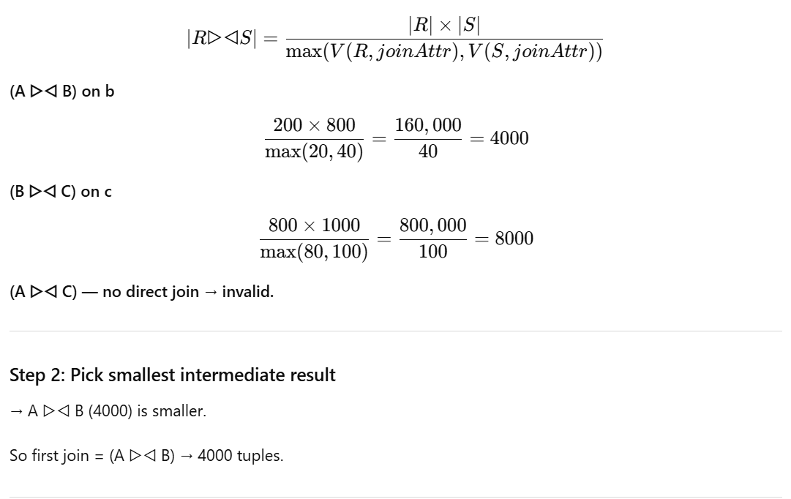

Step 3: Join result with C
Join on attribute c:

✅ Final join order: (A ▷◁ B) ▷◁ C
✅ Intermediate sizes: 4000 → 40,000
✅ Total cost (sum): 44,000

🧩 Question 5 — Index Join Cost
Given:
T(R)=200,000, B(R)=5,000
T(S)=80,000, B(S)=10,000
V(S,B)=80,000, V(R,B)=10,000
Index on S.B (4 levels)
B is key in S, foreign key in R

a) Index fully in memory
Each record of R finds one tuple in S via index.
Cost = Read R sequentially + one index lookup per tuple.
Cost = B(R) + T(R) × 0
→ Because all index levels are in memory (no disk I/O for index lookup).
But we must read matching S blocks (1 I/O each, assuming random access):
Each R tuple finds one S tuple:
- 200,000 lookups
- But S has 10,000 blocks → each lookup hits random block
If we assume buffering (say 10% reuse): ~180,000 I/Os for S.
Total cost ≈ 5,000 + 180,000 = 185,000
✅ Answer: ~185,000 I/Os

b) Only root of index in memory
- Root = 1 access (memory)
- 3 remaining levels → 3 I/Os per lookup.
- Plus 1 I/O for tuple in S.
So per R record: 4 I/Os.
Cost = B(R) + T(R) × 4 = 5,000 + 200,000 × 4 = 805,000
✅ Answer: 805,000 I/Os

🧩 Question 6 — Addressing, TID, and Swizzling

a) Physical vs Logical Addressing
Type | Description | Advantage | Disadvantage
Physical | Direct disk location (cylinder, track, block, offset) | Fast access (1 I/O) | Dangling pointers if record moves
Logical | Uses stable logical IDs; map table resolves to physical address | Flexible (records can move) | Slower (extra lookup)

b) Tuple Identifier (TID)
- Format: (Block ID, Slot/Offset)
- Purpose: hybrid approach combining speed and flexibility.
- If record moves within block → only slot table updates.
- If record moves to another block → old block stores a forwarding pointer (TID) to new location.
✅ Helps avoid dangling pointers efficiently.

c) Pointer Swizzling Strategies
Type | Description | Best When
Never swizzle | Always translate addresses via lookup table | Few pointer dereferences (saves memory)
Automatic swizzle | Convert all DB pointers to memory pointers immediately on load | Most pointers will be used
On-demand swizzle | Translate only when pointer first accessed | Moderate pointer usage (balanced trade-off)

✅ Summary (Q6):
- Physical = fast but unsafe
- Logical = safe but slower
- TID = stable hybrid
- Swizzling improves performance for in-memory pointer dereferences

